This Document contains Signature readings of the charging process when the phone is at different stats

To capture utilize the described set-up to observe the charging process of the phone. Each image capture below specifies the state the phone should be in when capturing with particular consideration of the current battery level and state of the phone (screen on/off, locked/unlocked, etc).

Capturing sampling rates are taken at 62.5 kS/s and 1 GS/s

All data is contained in the Signature Data folder and includes screen shots at each of the various sampling rates and associated csv files for all captures at 62.5 kS/s

100% Battery

Power Off - (Screen Off) : Signature A

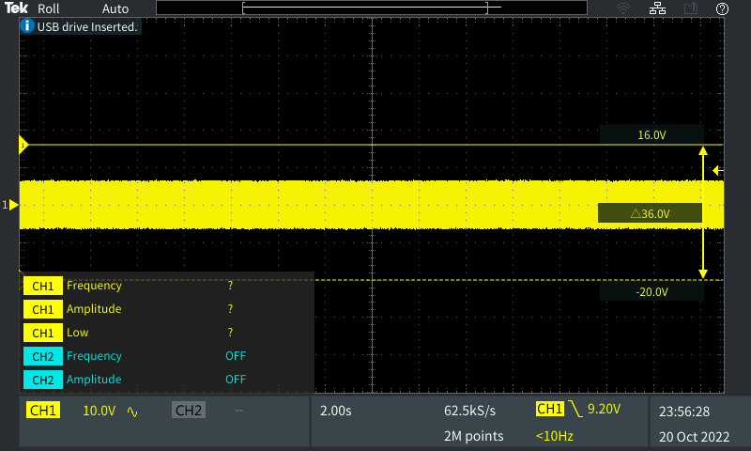

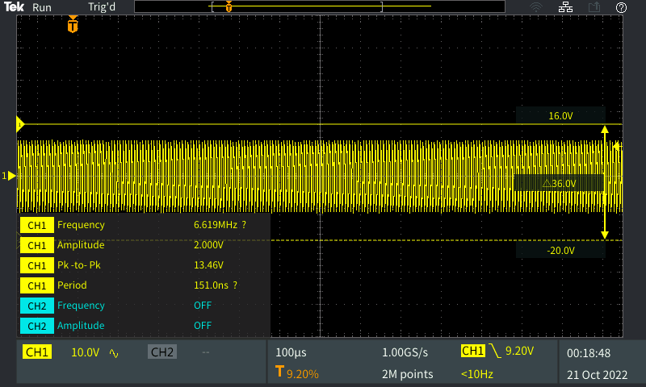

Power On - (Screen Off) : Signature B

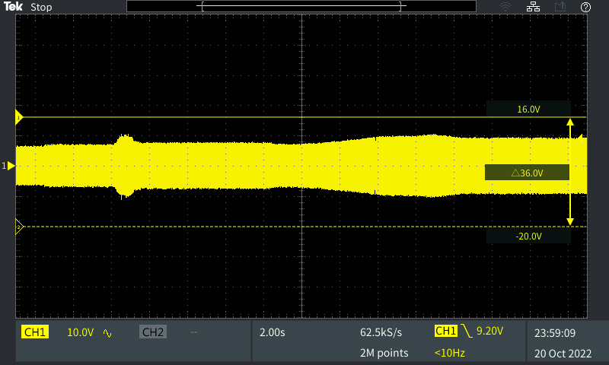

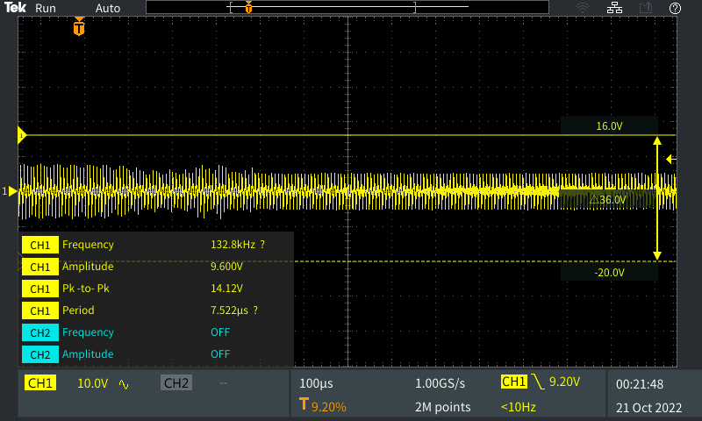

Power On - (Screen On – Lock Screen) : Signature C

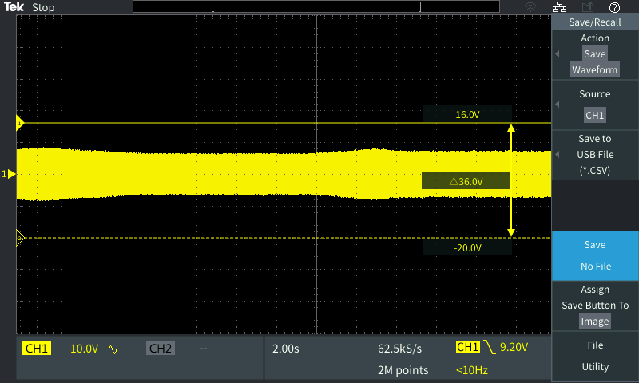

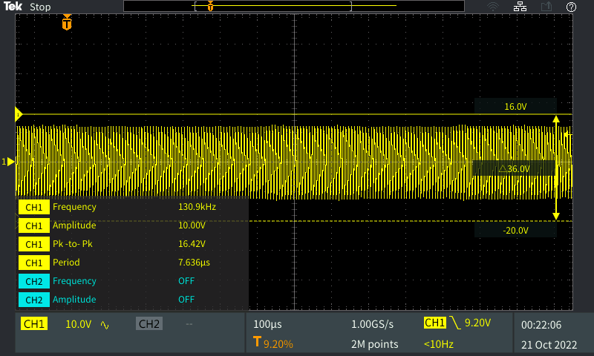

Power On – Unlocked : Signature D

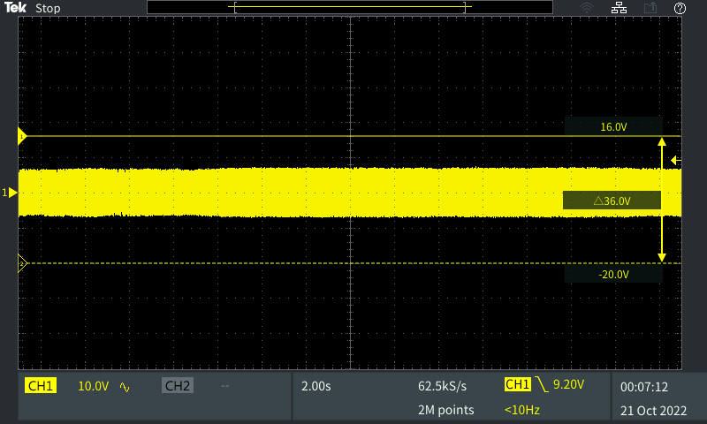

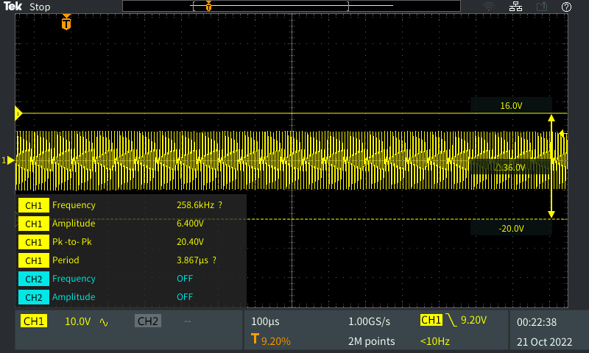

Power On – Flashlight On : Signature E

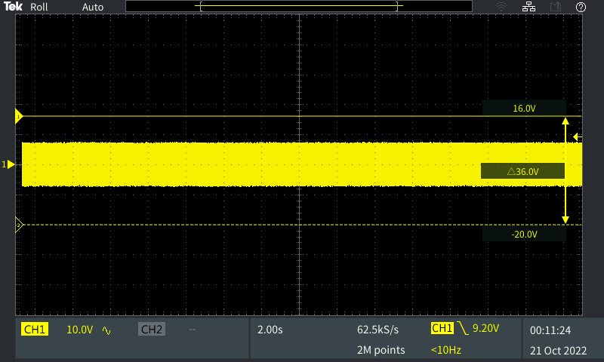

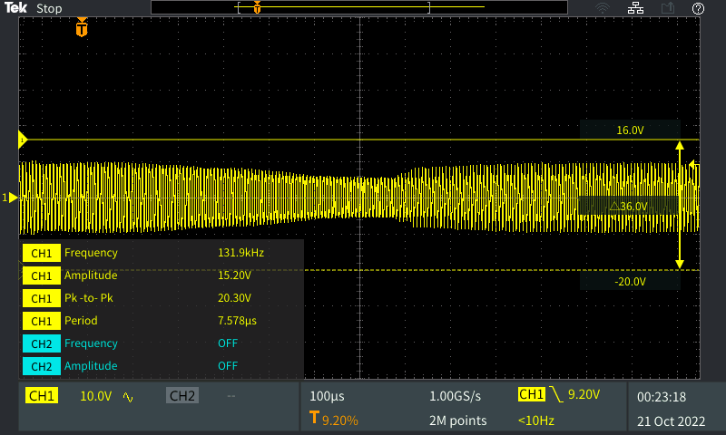

-----------------------------------------------------------------------------------------------------------------

50% Battery

Power Off - (Screen Off) : Signature F

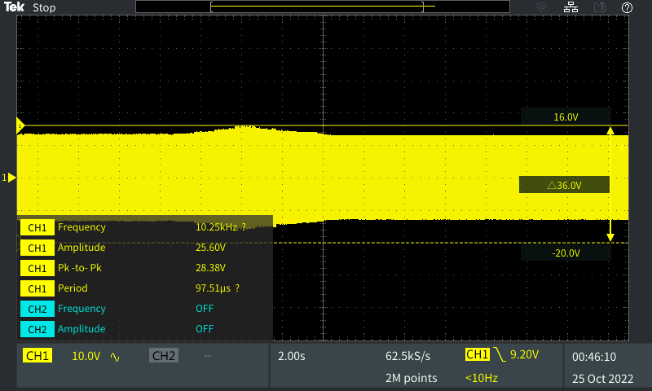

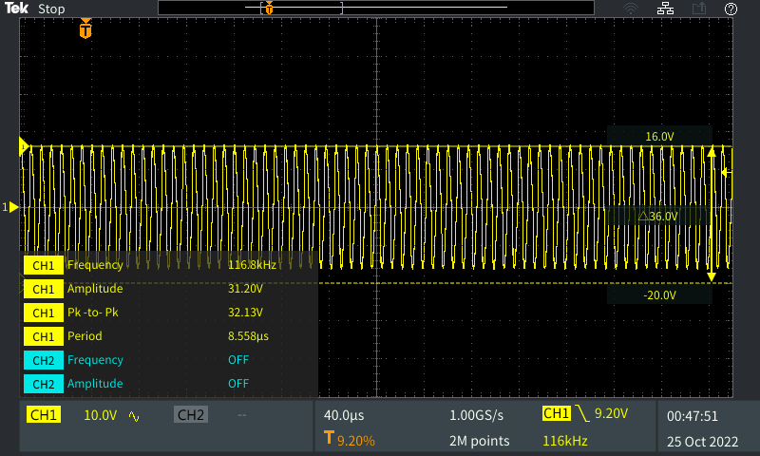

Power On - (Screen Off) : Signature G

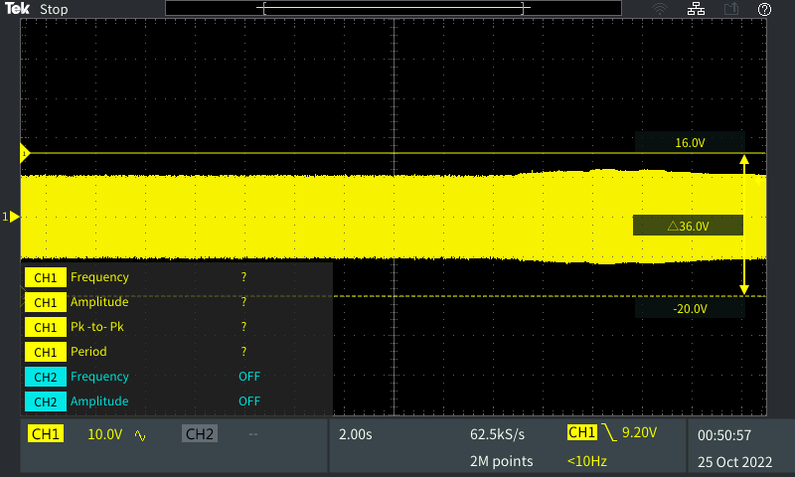

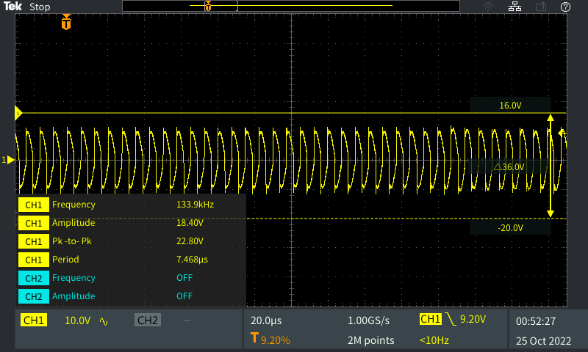

Power On - (Screen On – Lock Screen) : Signature H

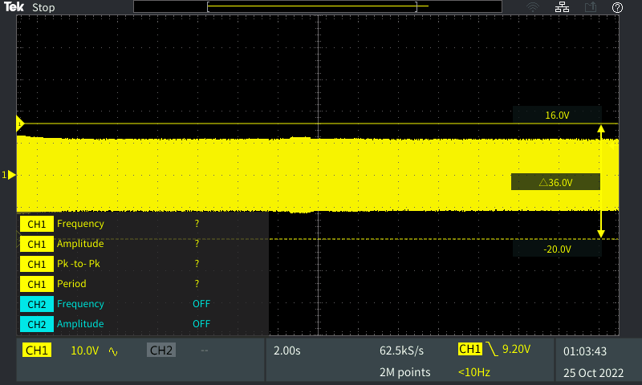

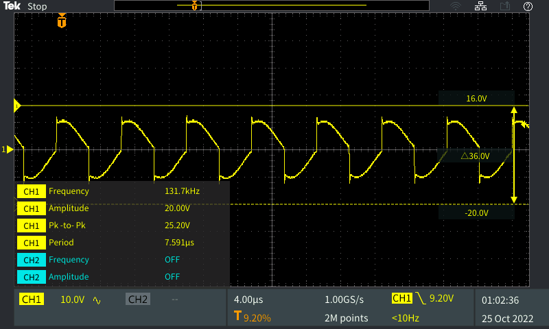

Power On – Unlocked : Signature I

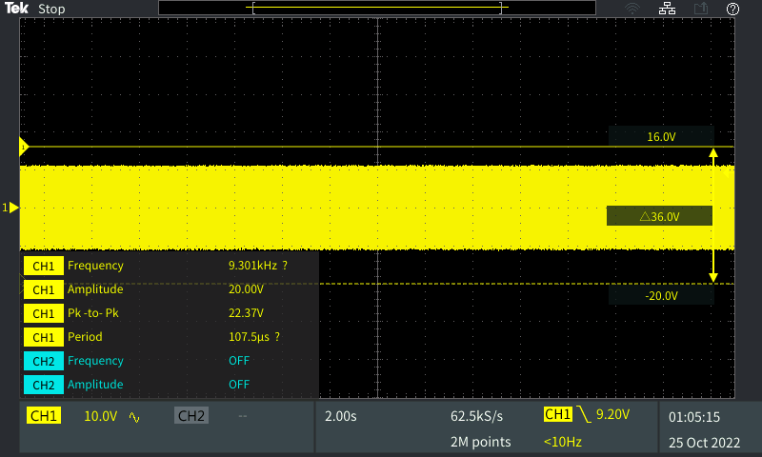

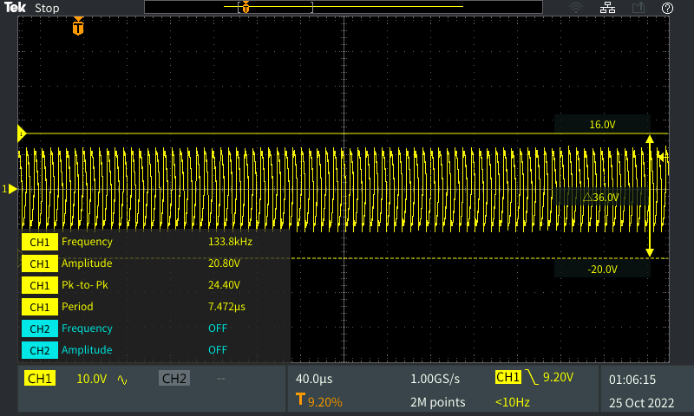

Power On – Flashlight On : Signature J

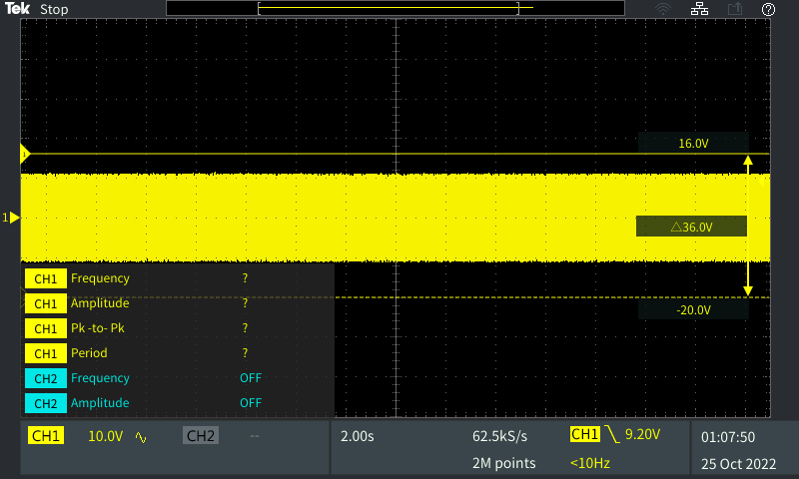

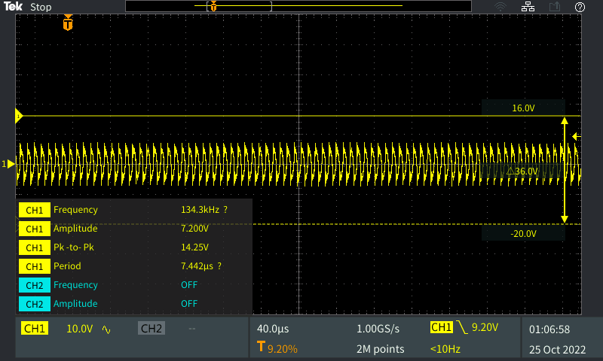

----------------------------------------------------------------------------------------------------------------------------------

0-5% Charge

Power Off - (Screen Off) : Signature K

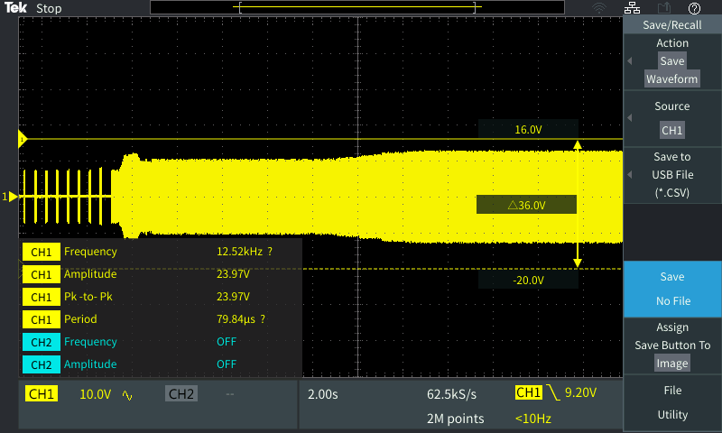

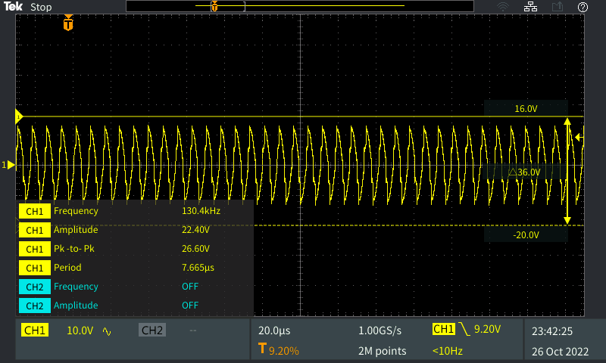

Power On - (Screen Off) : Signature L

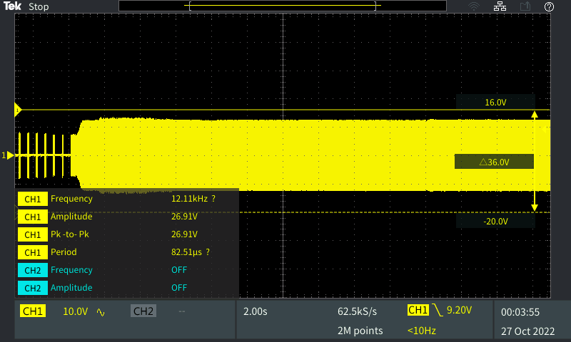

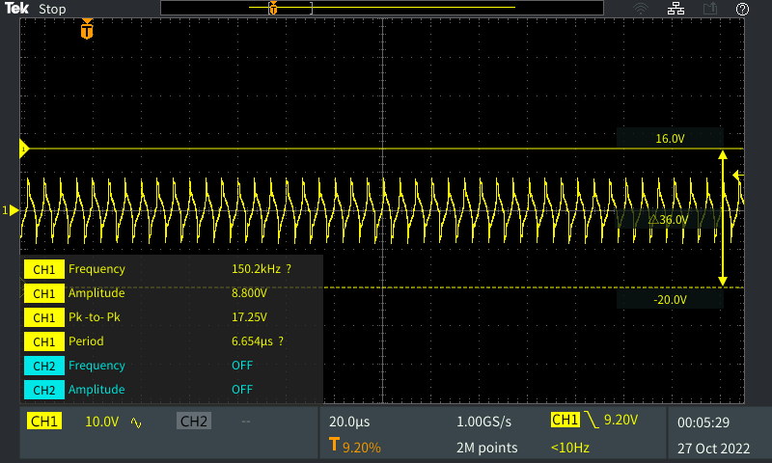

Power On - (Screen On – Lock Screen) : Signature M

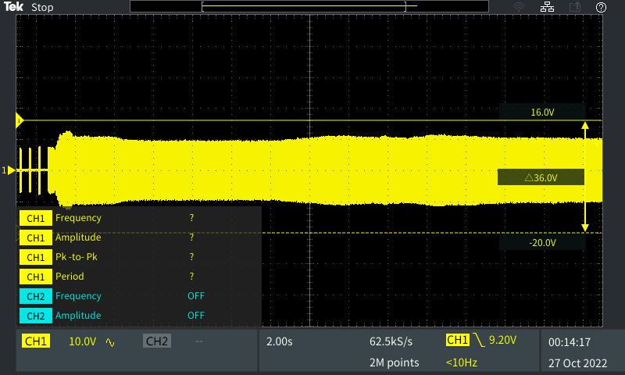

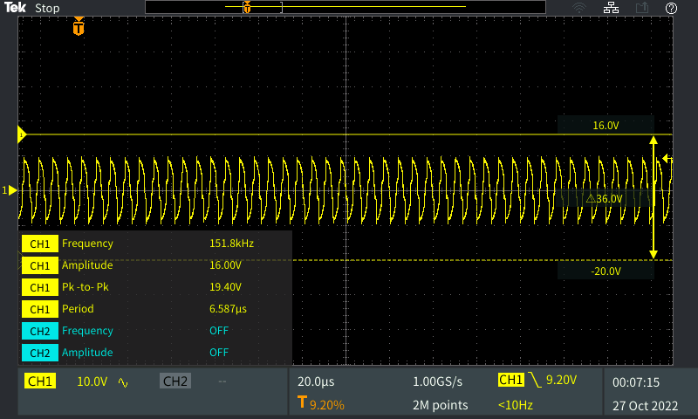

Power On – Unlocked : Signature N

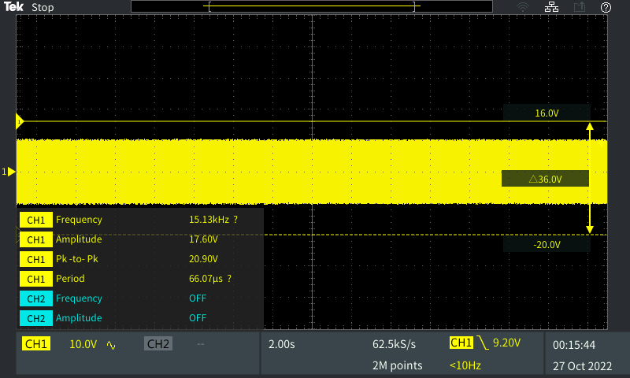

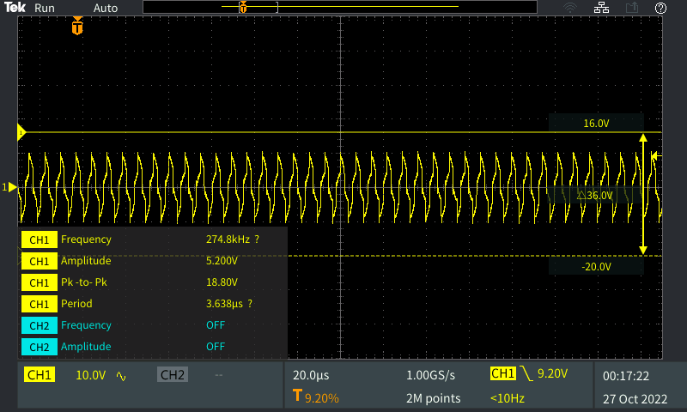

Power On – Flashlight On : Signature O

